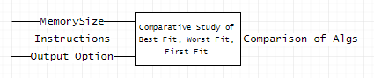

**Black Box Definition for Top Node**

**Input:** Inputted Size of the Memory, Sequence of Instructions, and Output Option.

**Output:** Organized comparison of all 3 memory allocation algorithms, outputted to user-described standard.

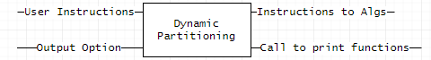

**Black Box Definition for Dynamic Partitioning Node**

**Input:** Given user instructions and output option.

**Output:** Sends instructions to Algorithms, calls print functions.

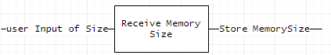

**Black Box Definition for Receive Memory Size Node**

**Input:** User inputted size.

**Output:** Stores the size of the memory to be executed upon.

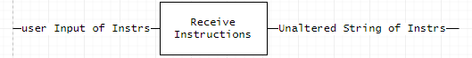

**Black Box Definition for Receive Instructions Node**

**Input:** Sequence of user inputted instructions.

**Output:** Stores unaltered string of instructions in preparation for dissection

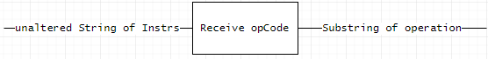

**Black Box Definition for Receive opCode Node**

**Input:** Unaltered String of user-inputted instructions.

**Output:** Substrings containing individual relevant segments of information within instruction string containing the action to be executed.

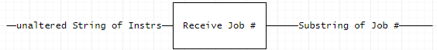

**Black Box Definition for Receive Job # Node**

**Input:** Unaltered String of user-inputted instructions.

**Output:** Substrings containing individual relevant segments of information within instruction string containing the Job #.

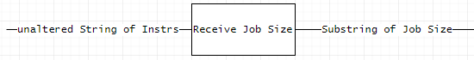

**Black Box Definition for Receive Job Size Node**

**Input:** Unaltered String of user-inputted instructions.

**Output:** Substrings containing individual relevant segments of information within instruction string containing the Job Size.

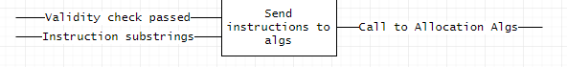

**Black Box Definition for Send Instructions to Algorithms Node**

**Input:** Substrings of instruction information & a Boolean variable stating the pass of a validity check.

**Output:** Individual calls to each allocation algorithm.



**Black Box Definition for Check Validity Node**

**Input:** Instruction opcode variable, so the function knows which instruction is trying to be performed. Job # of job to be checked for validity. List variable initiating validity check against a specific list.

**Output:** Individual calls to each validation algorithm.

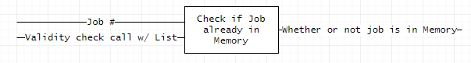

**Black Box Definition for Check if Job is Already in Memory**

**Input:** Validity check call from handler function, including Job #, List, and Instruction.

**Output:** Boolean whether or not job is already in Memory.

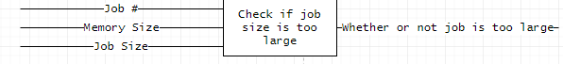

**Black Box Definition for Check if Job Size is too Large**

**Input:** Job #, Memory Size, Job Size.

**Output:** Whether or not job is too large to fit in Memory in current state.

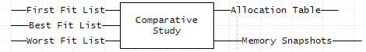

**Black Box Definition for Comparative Study Node**

**Input:** First Fit, Best Fit and Worst Fit Lists, altered entirely after instruction sequence execution.

**Output:** Allocation Tables & Memory Snapshots for each algorithm.

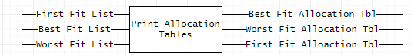

**Black Box Definition for Print Allocation Tables Node**

**Input:** First Fit, Best Fit and Worst Fit Lists, altered entirely after instruction sequence execution.

**Output:** Best Fit Allocation Table, Worst Fit Allocation Table, First Fit Allocation Table.

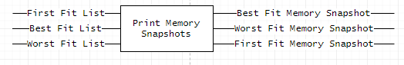

**Black Box Definition for Print Memory Snapshots Node**

**Input:** First Fit, Best Fit and Worst Fit Lists, altered entirely after instruction sequence execution.

**Output:** Best Fit Memory Snapshot, Worst Fit Memory Snapshot, First Fit Memory Snapshot.

https://puu.sh/xSHAf/0ea37c422f.png

**Black Box Definition for Print Comparative Results Node**

**Input:** User Option of output frequency.

**Output:** Call to print Allocation Tables & Memory Snapshots, as often as user prescribed.

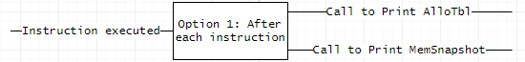

**Black Box Definition for Option 1: After each instruction Node**

**Input:** Instruction executed

**Output:** Call to print Allocation Tables & Memory Snapshots.

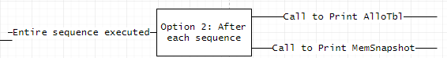

**Black Box Definition for Option 2: After each sequence of instructions Node**

**Input:** Entire sequence of instructions executed.

**Output:** Call to print Allocation Tables & Memory Snapshots.

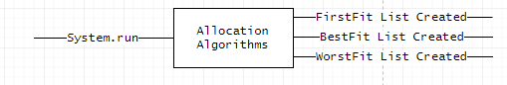

**Black Box Definition for Allocation Algorithms Node**

**Input:** System run.

**Output:** Creation of FirstFit, BestFit and WorstFit Lists.

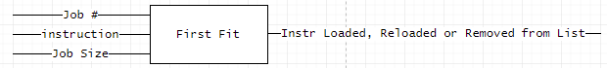

**Black Box Definition for First Fit Node**

**Input:** Job #, Instruction to be executed and Job Size.

**Output:** Instruction either loaded, reloaded or removed from List.

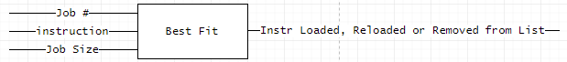

**Black Box Definition for Best Fit Node**

**Input:** Job #, Instruction to be executed and Job Size.

**Output:** Instruction either loaded, reloaded or removed from List.

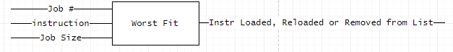

**Black Box Definition for Worst Fit Node**

**Input:** Job #, Instruction to be executed and Job Size.

**Output:** Instruction either loaded, reloaded or removed from List.

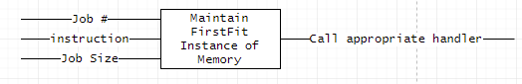

**Black Box Definition for Maintain FirstFit Instance of Memory Node**

**Input:** Job #, Instruction to be executed and Job Size.

**Output:** Call to appropriate handler, based off of instruction.

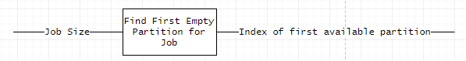

**Black Box Definition for Find First Empty Partition for Job**

**Input:** Job Size to be allocated.

**Output:** Index of first available partition to be allocated.

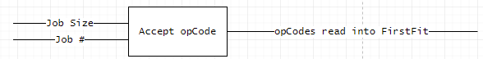

**Black Box Definition for Accept opCode Node (First Fit)**

**Input:** Job # and Job Size.

**Output:** opCodes read into FirstFit algorithm.

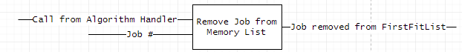

**Black Box Definition for Remove Job from Memory List Node (First Fit)**

**Input:** Call from Algorithm handler (to prompt removal), Job # to be removed.

**Output:** Job removed from FirstFitList.

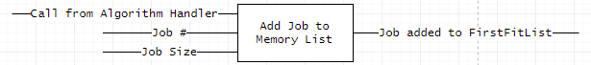

**Black Box Definition for Add Job from Memory List Node (First Fit)**

**Input:** Call from Algorithm handler (to prompt addition), Job # to be added, Job Size.

**Output:** Job added to FirstFitList.

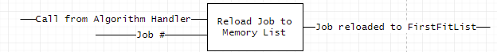

**Black Box Definition for Add Job from Memory List Node (First Fit)**

**Input:** Call from Algorithm handler (to prompt reload), Job # to be reloaded.

**Output:** Job reloaded to FirstFitList.

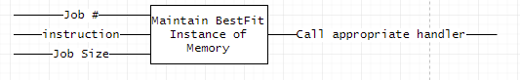

**Black Box Definition for Maintain BestFit Instance of Memory Node**

**Input:** Job #, Instruction to be executed and Job Size.

**Output:** Call to appropriate handler, based off of instruction.

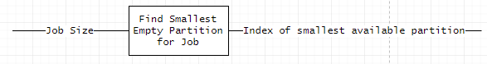

**Black Box Definition for Find Smallest Empty Partition for Job**

**Input:** Job Size to be allocated.

**Output:** Index of smallest available partition to be allocated.

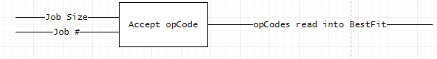

**Black Box Definition for Accept opCode Node (Best Fit)**

**Input:** Job # and Job Size.

**Output:** opCodes read into BestFit algorithm.

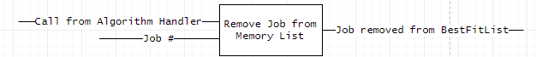

**Black Box Definition for Remove Job from Memory List Node (BestFit)**

**Input:** Call from Algorithm handler (to prompt removal), Job # to be removed.

**Output:** Job removed from BestFitList.

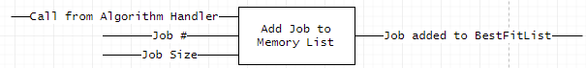

**Black Box Definition for Add Job from Memory List Node (BestFit)**

**Input:** Call from Algorithm handler (to prompt addition), Job # to be added, Job Size.

**Output:** Job added to BestFitList.

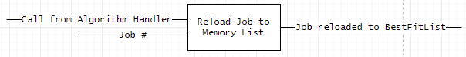

**Black Box Definition for Reload Job from Memory List Node (Best Fit)**

**Input:** Call from Algorithm handler (to prompt reload), Job # to be reloaded.

**Output:** Job reloaded to BestFitList.

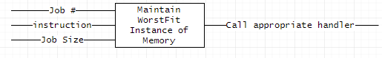

**Black Box Definition for Maintain WorstFit Instance of Memory Node**

**Input:** Job #, Instruction to be executed and Job Size.

**Output:** Call to appropriate handler, based off of instruction.

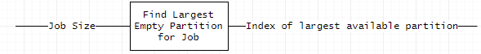

**Black Box Definition for Find Largest Empty Partition for Job**

**Input:** Job Size to be allocated.

**Output:** Index of largest available partition to be allocated.

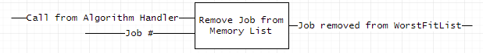

**Black Box Definition for Remove Job from Memory List Node (WorstFit)**

**Input:** Call from Algorithm handler (to prompt removal), Job # to be removed.

**Output:** Job removed from WorstFitList.

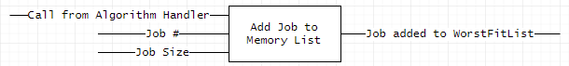

**Black Box Definition for Add Job from Memory List Node (WorstFit)**

**Input:** Call from Algorithm handler (to prompt addition), Job # to be added, Job Size.

**Output:** Job added to WorstFitList.

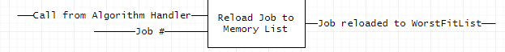

**Black Box Definition for Reload Job from Memory List Node (Worst Fit)**

**Input:** Call from Algorithm handler (to prompt reload), Job # to be reloaded.

**Output:** Job reloaded to WorstFitList.